
Company
Logotype

Cone Beam Computed Tomography- Report



Porur Dental X-rays & CBCT

Patient Name : Mrs. Virtika | Date of Report : 02.07.2024
Age/ Gender : 19 years/ Female | Region of Interest : CBCT Mandible
Referring doctor: Dr. Lakshmi | Indication : I.A.Nerve proximity to 38
Clinical Notes: Nil
PATIENT INFORMATION

CBCT- Mandible provided
CBCT – IMAGE DETAILS

RADIOGRAPHIC INTERPRETATION

- The tooth 38 is present with dental caries involving the pulp.
- The long axis of 38 appears to be parallel to the long axis of the adjacent 37 tooth.
- The crown of 38 is present partially within the ascending ramus of mandible.
- The tooth 38 is present towards the lingual aspect
Width of buccal cortical bone: 2.92 mm ; Width of lingual cortical bone: 1.03 mm
- Distance between the root of 38 and the Inferior Alveolar Nerve canal: in contact.
- Kindly note: curved root apices present in relation to 38.

RADIOGRAPHIC IMPRESSION

- Dental caries and partially impacted tooth: 38

Kindly correlate with clinical findings


IMAGES FOR REFERENCE

RECONSTRUCTED PANORAMIC VIEW
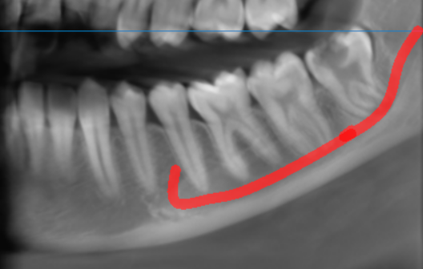

3-DIMENSIONAL VIEW

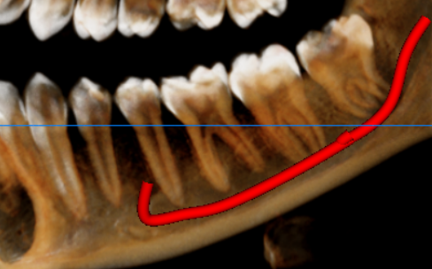

CROSS SECTIONAL VIEW

38 region- relation with the inferior alveolar nerve canal | 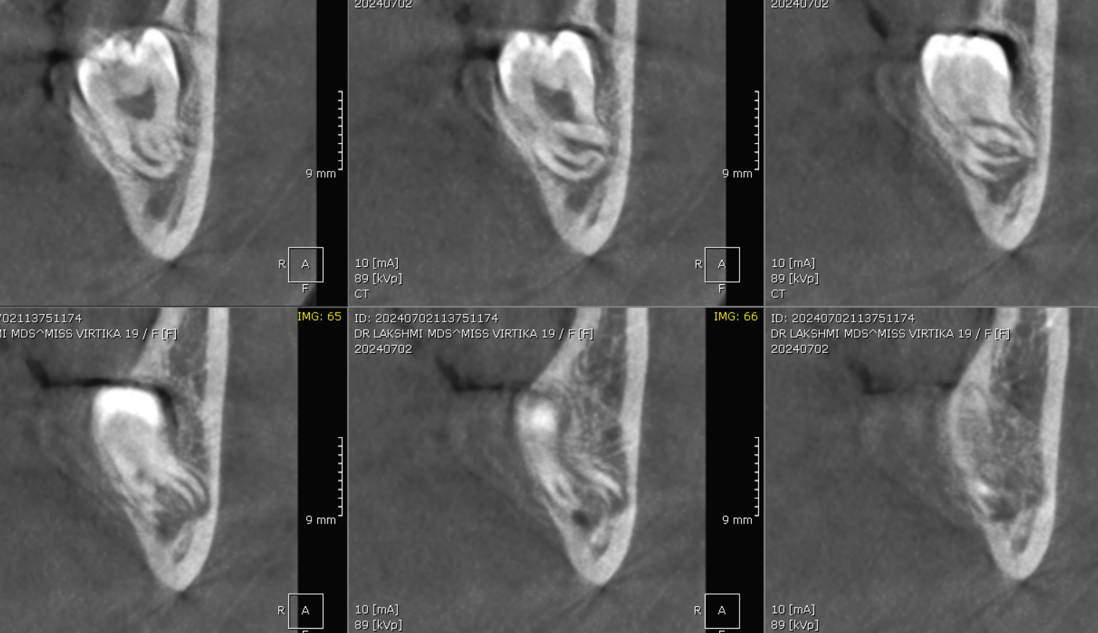  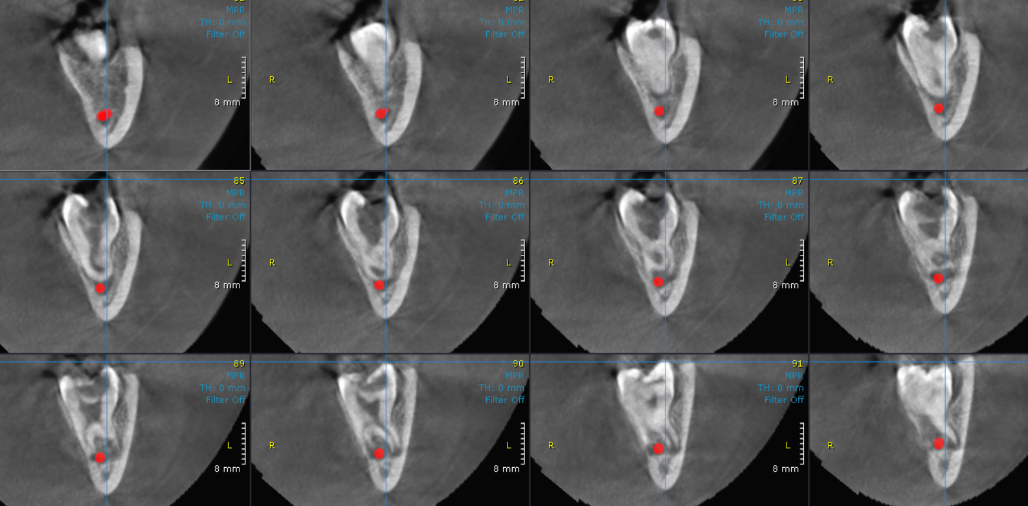

**** End of report ****

